What's Happening to the Mekong River?
-Survey of Cross-border Environmental Impacts in Northern Laos-

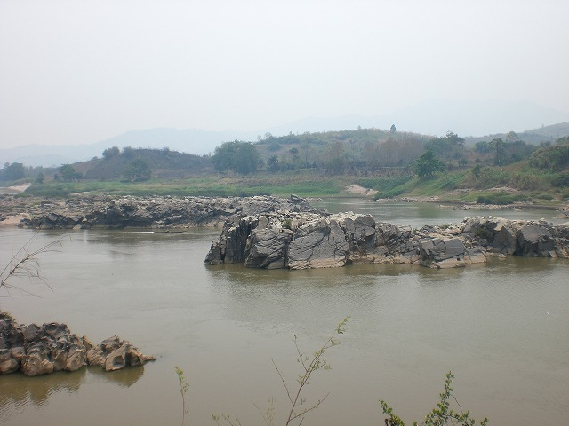



May 21, 2007

In April 2007, I visited Houay Xay District, Bokeo Province located in Northern Laos to observe environmental changes along the Mekong River, particularly cross-border environmental problems (Note 1). Our survey indicates that there have been major environmental changes such as abnormal fluctuations in water levels, especially over the past several years. These changes have caused large-scale riverbank erosion and depletions of fish stocks, threatening the local residents' livelihoods. There have not yet been sufficient scientific studies of the causes of the water level fluctuations, riverbank erosion, and decrease in fish populations. However, according to those who live among the Mekong River, these abnormal environmental changes may be the result of problems caused by the development operations and commercial activities of other countries, including dam development and commercial shipping from China, previous revetment construction conducted by Thailand to prevent riverbank erosion, and blast fishing by Chinese commercial vessels or people in Thailand and Burma.

< Singkham Village, Tonpheung District>
"In the past, I could stand on the riverbank and throw rocks into Thailand (on the opposite bank) and we could watch pretty girls bathing on the other side."

Khamsan, an elder of Singkham Village, jokes when he speaks of the changes to the river, but this village has been hit hard by serious riverbank erosion, to the point where some residents have been forced to leave.

Riverbank Erosion and the Formation of Sandbars
Erosion is particularly bad during the rainy season, but even during the dry season the riverbanks are receding little by little each day.
Singkham ｉs across the Mekong River from H Village in Chiang Kong District, Chiang Rai Province, Thailand.
In 2003, bank protection work was carried out at a point a bit upstream of Had Pai Village. Starting around that time, riverbank erosion became severe. “Thailand has the money for protective measures, but all Laos can do is take the damage” said a villager.
According to Khamsan, a corn fields
which until few years ago measured about 50 meters from the river is now less than 20 meters away. The difference, of about 30 meters, has eroded away. Furthermore, a sandbar was formed in the Mekong River 2 to 3 years ago. As the slope of the riverbank became steep due to the erosion, villagers no longer are able to bathe in the river by the riverbank. They now go to the sandbar with a small boat to take baths.
Asked about the causes of such riverbank erosion and the formation of the sandbar, a villager responded: “I’m not sure but it could be a result of the bank protection work on the Thai side. It was after the work that the sandbar was formed and the riverbank erosion became severe.” “It may also be an impact from waves created when Chinese ships pass by”, said another villager.

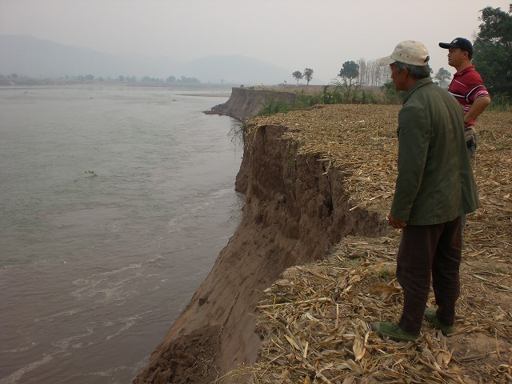
A corn field erodes a bit each day
(Singkham Village, Tonpheung District)
Fluctuation of the Mekong River’s Water Level
In the past 2-3 years, the river’s water level fluctuates greatly throughout the day. “In the past, volume of water never changed this much in the morning and in the evening”, said a villager.
In addition, fishing has become difficult due to the lack of water. Villagers conclude that the cause of the problem “may be due to erosion filling up the bottom of the river.” In the past, about 2 to 3 Chinese commercial ships a month passed by even during the dry season. However, no such ships have come this year because the water level is so low.

Villagers’ Concerns
“The river is now only 40 meters away form the village temple. If [riverbank erosion] reaches the temple and residential area, we will have to relocate the village.”
“In 2003, we raised money and installed electricity on our own. I don’t want to move now that our lives have become more convenient. Also, we still have to pay back our debt for the electricity installation.”

Concerns were voiced by the villagers of Singkham one after the other. Villagers have requested the government to take measures to deal with these problems. However, there is no clear vision for the future.
About a half of the households in Singkham Village own paddy fields. Those without paddy field raise corn or provide labor to the families with paddy fields. Almost all the rice necessary to feed every family in the village is produced within the village. The village seems relatively economically stable, but if the village continues to suffer, it may be forced to relocate within few years. Together with damage to farmland, villagers’ living conditions may worsen.

< Donesavane Village, Tonpheung District>
Singkham Village's fears became reality for Donesavane Village in Tonpheung District.
According to the Tonpheung District Office, of the 52 villages in the district, 36 are located on the Mekong River. More than 20 of those have been affected by riverbank erosion. Riverbank erosion has been noticeable since the 1980s and became a serious problem starting around 2002. The worst-affected areas have seen erosion destroy the land several hundred meters from the original banks. Residents of 7 villages have had to move because of the riverbank erosion, and in hardest-hit Donesavane village all 146 households relocated in 2002.

Riverbank Erosion and Relocation
Large Chinese commercial ships began running along the Mekong River starting in 1999. The destruction of riverbanks began in 1987, but it only started becoming a serious problem after 1999. Village Chief Sukhanthong emphasized the scale of the damage: "The District Office was once 2km from the riverbank but now it is only 500m away." He claimed that the village has lost 200m of land in the past year alone and was uncertain about the future: "This will continue unless some measures are taken. There are plans to undertake revetment construction in 7 areas of the district, but it is uncertain whether it will actually take place."
When asked about the causes of the riverbank erosion, one villager responded, "It's probably an effect of the Chinese dams. When Chinese commercial ships pass through, they open the dam and increase the water level to make it easier for ships to pass."
The residents of Donesavane Village were forced to relocate in 2002 when the impact of erosion became too much to withstand, and the relocation was completed in September 2002. In addition to their residences, agricultural land has also been damaged. A 6-7 hectare corn farm was lost to the erosion, affecting 15 households.
Reflecting on the relocation, the Village Chief explained, "It was good that electricity and plumbing were installed. Also, we are no longer impacted by flooding since we are now far from the banks." However, he admitted that the villagers bore a substantial burden for the relocation. Their present location was agricultural land owned by the people of Donesavane Village, so they had to pay 4,000 baht apiece (approximately 15,200 yen) to buy it from the villagers. The national government built a school along with the relocation, but the villagers paid other relocation costs themselves.

Impact on the Fishing Industry
Currently, it is possible to catch 20kg of fish in a day on the Mekong, but there were even more fish in the past, villagers report. The Village Chief claims that fish supplies began to decline in 2000. Stocks of Pa Sagoua (a local relative of the catfish), Pa Khe, Pa Kot and Pa Nai have declined, he said.
Also, there have been cases of fishing boats, anchored on the water, being washed away by sudden surges in the water level.
I was told that the primary reason for the decline in fish population was the use of electric shock and blast fishing by villagers. They say that the methods are often used on the Thai side. Blast fishing was banned in Laos as of 2005, and as a result the fish population has bounced back slightly. A second reason given was the dynamiting of rapids in China.

<Tonpheung Village, Tonpheung District>
Tonpheung Village has a small pier for boats crossing the river into Thailand, through which pass small boats carrying agricultural products and other goods. Chinese ships do not anchor here, but there is a sign indicating the distance (272.2km) to the Chinese border.
Here, I spoke with Pheng (not his real name), who makes his living as a boat operator and fisherman in addition to working on rice paddies.
Pheng hails from another province of Laos but has worked in the area as a boat operator since 1970. Seven ships operate out of the pier, and Pheng operates them on a rotation of once every 5 days.
Fishing is carried out in groups of 3 between December and May. Pheng claims to catch anywhere between 10-20kg of Pa Phia, Pa Kot, Pa Khao (a local species of carp) and Pa Khe per day. Pa Khe sells for 180 baht (about 700 yen) per kilogram, and together the 3 make as much as 1,000 baht (about 3,800 yen) per day.

The Decline in Fish and River Kelp and Causes
Pheng commented, "There are fewer fish than there were in the past" and noted that Pa Man muu (a local species of loach) and Pa Fa Lai (batoideas) have declined to the point where he can only catch one per year if he is lucky.
The primary reason for the decline is the increase in the number of people who use electric shock and blast fishing. He says the some people continue despite the ban. There is actually a village that continues blast fishing upstream from Tonpheung Village. A second reason is the change in water levels. The water level rises midday and recedes at night. Some days the water level fluctuates by 20-50cm. He blames Chinese dams.
There is also impact from Khai (river kelp). If the water levels rise and fall naturally there is no problem, but sudden changes to the water level bring Khai to the surface and dry it out.

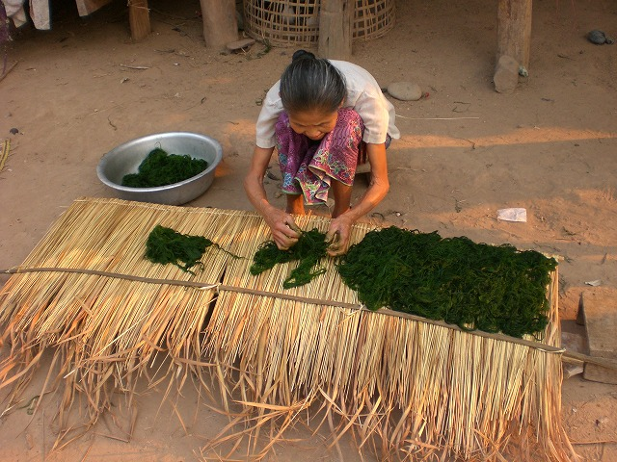
A woman processing Khai (river kelp)
(Houay Tang Village, Tonpheung District)

Riverbed Erosion and the Expansion of Sandbars
When Pheng moved to the village in 1970, the sandbar in the front of the village "was not this big" he says.
Back then, there was land 200m inland from the current riverbank. Riverbank erosion began in 1985, he said.
He cited the revetment construction that took place on the Thai side and changes to the river flow as causes of this problem. Pheng explained that revetment construction undertaken by the Japan International Cooperation Agency (JICA) to stop the riverbank erosion has had some effect, but four years ago the villagers took the initiative in planting Mai Ya Lap (Mimosa pigra) to stop the erosion. The plant is effective in stopping erosion, but it also has a high level of fecundity and has already become a destroyer of natural ecosystems in Thailand. The International Union for the Conservation of Nature (IUCN) has listed the plant as a dangerous alien species. In fact, I confirmed that the plant has been growing in areas around the village even in areas quite far from the riverbank.

Passage of Chinese Ships
Chinese ships began passing through these waters in the late 1980s, and from the late 1990s onward 80-ton ships and larger began passing.
Currently, 300-ton ships are reported to pass through the area during the rainy season, and more than 10 ships navigate the river each month in that period. The Chinese ships observe regulations during the day, but at night they take advantage of the fact that no one is watching and traverse the river at higher speeds. Villagers suspect that the intense waves caused by the vessels traveling at high speeds contribute to the erosion.
A second port is currently being planned for Chiang Khong, and Pheng noted that if 500-ton ships begin passing through the impacts will grow even worse.
According to him, when 5 or more Chinese commercial ships pass, the ships contact authorities in China who release water from dams. He claimed that this is causing the irregular water level fluctuations.

A Protected Area for the Fish
Efforts to protect their dwindling maritime resources have begun at Tonpheung Village. A no-fishing zone was established in 2006. The village is following the example of efforts on the Thai side, which have succeeded in restoring fish populations by creating a no-fishing zone that protects the fish’s hatching and feeding grounds. The no-fishing zone extends for approximately 150 meters and the villagers are waiting to test the results.

<Ban Mom Port>
Ban Mom Port is located near the Golden Triangle. Built in 2001 with funding from the Laotian government, it only recently opened in February 2007 as an international port at which Chinese ships can anchor. I spoke with Somphong, the manager of the port.
Somphong notes that at busy times around 15-20 Chinese ships pass through per month. Most ships are 150-200 tons, but 300-ton ships also pass through. Almost no Thai ships pass through.
The main exports from Laos are non-lumber forestry goods, such as mak tao (gourd), and corn, of which a total of 100 tons are exported to Thailand. There are two Laotian corporations in Luang Namtha Province and Bakeo Province that conduct the exports.
Though it opened as an international port, most Chinese and Thai ships only pass through Ban Mom. The port does almost no business with Burma.
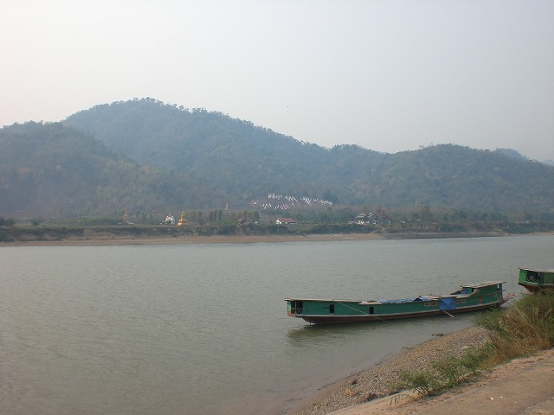
The view of Burma from Ban Mom Port, on the other side of the Mekong
Somphong explains, “We have a new port, but the roads are inconvenient and there is no electricity.” However, based on agreement between countries in the region, commercial ships passing through must anchor at the port and pay a 500-yuan (approximately 8,000 yen) toll.
According to a report from UNESCAP, Ban Mom Port is one part of the Laotian government’s new economic development zone (See: http://www.unescap.org/ttdw/Publications/TPTS_pubs/pub_2307/pub_2307_ch11.pdf), but in fact it is nothing more than a stop on the way between Thailand and China. Except for the tiny amount of forestry products that are exported to Thailand, it serves little purpose other than as a place to collect tolls.

<Tang Or Village, Tonpheung District>
I next took a speed boat 50 minutes from Ban Mom Port to visit Tang Or Village, where the Lue people live.

Decline in Fish Population and Changes to the Local Fishing Industry
Only around 12 households make their livings fishing in this village. They go out in teams of 3 or 4 and spend about 5 days out fishing at a time. Each trip earns a team around 15,000-20,000 baht (approximately 57,000-76,000 yen)
Fish caught in the area include Pa Khe and Pa Nai (a member of the carp family), but fishermen report that the fish populations have declined compared to what they were. In the past, 4-5 kg of fish could be caught with each casting net, but now casting nets are almost never used anymore since they have become ineffective. Instead, fixed nets are now most commonly used. One villager told me, “Chinese ships have been causing waves since they started passing by, and now fishing has become more difficult.
Chinese ships started traveling through the area in 1985, and large ships started coming in 1999. The ships once came each week even in the dry season, but people have not seen ships in this year’s dry season because there is not enough water for them.
Blast fishing is common. Chinese ships are the main culprit, using blast fishing to feed their crews, but some people in this village have bought explosives from the Chinese and do their own blast fishing. People say they hear the sound of explosions every day.
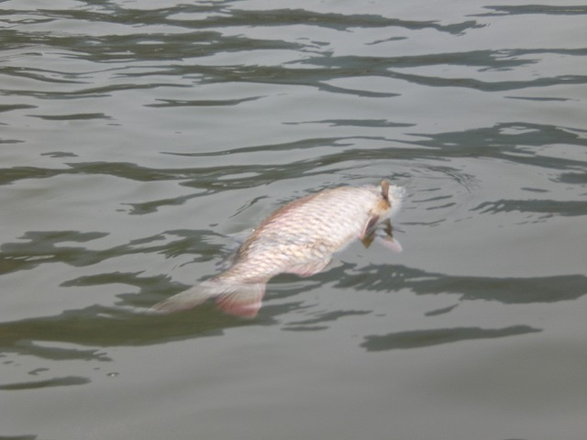
We saw dead fish floating in the water on the way to Tang Or Village. The boat operator explained that they most likely died from the impact of blast fishing.

<Fishermen Pitching Tents on the Sandbar>
On the way back from Tang Or Village to the Ban Mom Port, we met fishermen who were catching fish while living in tents patched on a sandbar near Houay Lom Village.
We interviewed Si (not his real name) from Houay Tap Village, Houay Xay District. He and his 5 teammates spent 7 hours to come here from Houay Lom Village by motorboat. Since 2 weeks before our visit, they had been catching fish and sleeping in tents pitched on the sandbar. Si had been fishing here for more than 15 years. He said he came here to catch fish because there are too many people in Houay Xay District and the current of the river around his village is too fast to for fishing.

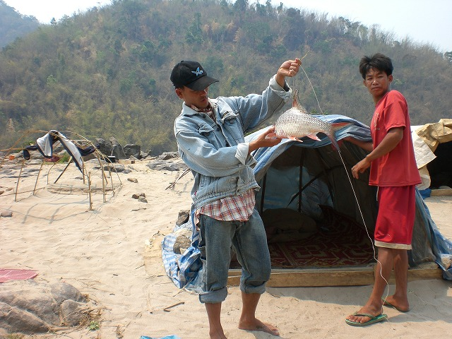
Fishermen showing off a freshly caught Pa Jook.

“We need to make money for Lao New Year” Si said. According to him, they can earn 7,000-8,000 baht apiece in a week.
They sell fish to middlemen who come to the sandbar by speed boats. They sell Pa Jok for 150 baht/ kg, Pa Ket (a genetic name of some species which have scales, mainly the carp family) for 100 baht/ kg, and Pa Nan (a general term for some species of fish with no scales, mainly the catfish family) for 15 baht/ kg.
They use Mong (a gill net) and Bet (a fishing hook) for fishing. They come to catch fish in April-May and July-August, and cultivate upland rice and vegetables in other season.

Decline in the Fish Population and Causes
Si said there had been more fish before and he had been able to earn about 10,000 baht (about 38,000 yen) by fishing for 2-3 days. When we asked him its causes, he said “some people do blast fishing. It causes decline of fish.” They themselves have never engaged in blast fishing. Moreover, he said that irregular fluctuation in water level is also one factor in the decline of fish stocks. “China raises water levels to make Chinese commercial ships navigate easily.” According to him, 3-10 Chinese ships pass about 3 times a month. “We cannot catch fish when Chinese ships come. So the only thing to do is let the ships pass,” he said.

<Si Mouang Ngam Tai Village, Thonepheun District>
Si Mouang Mouang Ngam Tai Village is located on the opposite side of Chiang Khong District, Chiang Rai Province of Thailand, across the Mekong River. We interviewed Maisam, a resident of the village.
According to Maisam, villagers go fishing from March to May. A group of 3-4 villagers can catch about 15kg of fish in a day. Villagers use fishing nets, and blast fishing is banned in the village.

Riverbank Erosion and the Formation of Sandbars
Si Mouang Mouang Ngam Tai Village is also affected by serious land erosion. The land where a elementary school and a playground were located has fallen down into the river and 11 rai (1 rai = 1600 square meters) of orange grove has also disappeared. According to Maisam, the impact of land erosion has been serious since river-protection works began in the opposite side of the village.
Water level changes unnaturally, increasing in the morning and decreasing in the evening. Especially, it has become remarkably in these two years. In rainy season (September to November), the impact is very serious.
Sandbars in the front of the village appeared in 1980s and has become bigger since 1995.

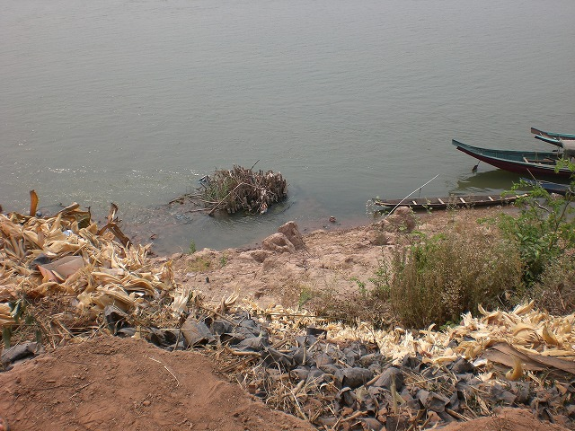
This bamboo, now submerged in the river, was growing on the riverbank the year before. (Si Mouang Ngam Tai Village, Thonepheun District)

Chinese Commercial Shipping
Many Chinese commercial ships run through the area when water levels are high, with 4-5 passing per day, according to the people we talked to. The ships bring asphalt and rubber from China to Thailand.
Chinese ships ran through the area at this time of year last year, but they have not come this year because there is not enough water.
Maisam noted that the ships cause large waves as they pass and claimed that they have even overturned smaller boats.

< Pak Ngao Village, Houay Xay District>
I paid a visit to Sangkhom, said to be the best fisherman in Pak Ngao Village at the mouth of the Ngao River, a tributary of the Mekong.
40-50 of the more than 120 households in Pak Ngao Village make their living fishing.
Fishing goes on year round on both sides of the N and Mekong Rivers using both casting and fixed nets. Since the fish population has declined compared to before, people now use nets with finer thread to make it easier to catch fish.

Decline in Fish Population and Causes
In the past, it was possible to catch 20kg of fish per day close to the village, but population growth and the receding water level have taken a toll on fish populations. Fish species Pa Waa and Pa Kaeng have almost completely disappeared, villagers said. Pa Fa Lai still exists in the Mekong, but it is no longer caught in the Ngao River.
In addition, it seems that blast fishing by Chinese ships in the Mekong is a major cause of the decline in fish population. One villager noted, “We saw Chinese ships doing blast fishing just last month, but we villagers can say nothing.”

--------------------

Observations

On this trip to northern Laos, I saw that the environmental changes to the Mekong River are having an even bigger impact on the Laos landscape and people’s lives than I expected. In my interviews with villagers and government officials, the main problems cited that are caused by the changes to the Mekong River that directly affect people are riverbank erosion and the decline of fish populations.

Riverbank Erosion
Serious damage from riverbank erosion has been reported in Thailand as well, but in Laos erosion is occurring at a pace of tens to hundreds of meters per year. People have lost agricultural land and homes to erosion, and there have even been cases such as Donesavane Village in which all residents were forced to relocate.
Specific measures are not being taken in most areas. People in Tonpheung Village have planted Mai Ya Lap (Mimosa pigra) around the riverbank as a countermeasure. Though the plant is somewhat effective in fighting erosion, it is also a dangerous destroyer of ecosystems.
When we asked villagers what they understood the cause of the riverbank erosion to be, they gave the following replies: (1); Irregular fluctuations in water levels due to impact from Chinese dams; (2) Waves caused by Chinese ships; and (3) Revetment construction in Thailand. What I heard several times in each village I visited was “When Chinese ships pass, China opens dams and adjusts the water level to make it easier for them to sail.” This has not yet been confirmed, but I heard complaints in several places that “water levels rise only when Chinese ships pass.” If the rumors are true, this would present a major problem: China has been prioritizing its own economic development and as a result is causing enormous damage to the environments of Laos and Thailand and people’s livelihoods.
Another new problem that we observed was that the revetment construction in Thailand is having a major impact on Laos. Chiang Khong District in Thailand reportedly gave no explanation to Bokeo Province and Tonpheung District when it undertook the revetment. Laotian villagers note that “Thailand has money so they can take countermeasures, but all Laos can do is take the damage.” The issue has led me to appreciate the need for information-sharing between countries on ecological management.

Decline of Fish Populations
According to villagers, fish populations are in relative decline. Reasons cited for this included: (1) Irregular fluctuations in water levels; (2) Dynamiting of rapids; and (3) Blast fishing.
Blast fishing is used by residents of villages in Laos, Thailand, and Burma, and is one cause of the decline in the number of fish, but Chinese commercial ships are using blast fishing to feed their crews. This has developed into a major problem as they use a large amount of explosive, and it is hard for people to request improvement since because it is impossible to monitor.
Meanwhile, we also found that some sharing of experiences for the sake of environmental protection has been taking place among neighboring villages separated by national borders. For instance, Tonpheung Village has followed the example of Thai villages and is testing out a no-fishing zone.

In order to lessen environmental impacts that cross national borders, it is crucial for countries in the region to dialogue with one another as well as for studies in the natural and social sciences to be undertaken. However, China, which is planning 14 dams in the upper Mekong (of which two are operational and another two are under construction) and has dynamited rapids to allow commercial ships to pass, seems to have little interest in the effect their efforts are having on downstream nations. A citizens’ group operating in northern Thailand has begun a movement to demand compensation from the Chinese government, but the outlook for that remains uncertain indeed. If each country sees only to its own interests when carrying out development projects, these cross-border economic problems will continue to worsen and threaten the livelihoods of the people who live either along the Mekong River or depend on its natural resources for sustenance.

Note 1: This survey was conducted between April 3-6, 2007 with the accompaniment of Dean Dr. Somkiat and Deputy Dean Dr. Somchanh of the Laos National University Faculty of Science. The areas visited are as follows: Technology and Environment Office of Bokeo / Tonpheung District Office/ 8 villages in Thonepheun District (Singkham, Donesavane, Tonpheung, Houay Tang, Tang Or, Houay Lom, Luang Singchai and Si Mouang Ngam Tai) / Ban Mom Port and a banana plantation owned by a Chinese company / 1 village in Houay Xay District (Pak Ngao).

Written by Satomi Higashi

Mekong Watch
2F Maruko Building 1-20-6 Higashi-ueno Taitou-ku Tokyo 110-0015
Tel: +81-3-3832-5034
Fax: +81-3-3832-5039
E-mail: info@mekongwatch.org
Website: www.mekongwatch.org

